# GTX 970 vs GTX 1060 3gb

Preferring one among GTX 970 and GTX 1060 3GB has always been a controversial topic. Both the updates of the graphics card have their specification and remarks. Some clear features such as the memory, Vram, CUDA cores, Core clock speeds, Architecture, and most importantly the performance rate along with benchmarking.

## GTX 970 vs GTX 1060 3gb

According to users, most of them don’t wish to upgrade to GTX 1060 3GB and prefer to run with GTX 970. Then again there is a large portion who declares GTX 1060 3GB as a better option for the long run. The following section will be on each of the graphics cards.

### GTX 970

GTX 970 ensures a better environment for all modern games and the architecture it follows is Maxwell 2.0. If we are to talk about the process, it is built on a 28nm process, that has 5,200 million transistors. The core features include a 1664 shading count with 104 texture mapping units and 56 ROPs.

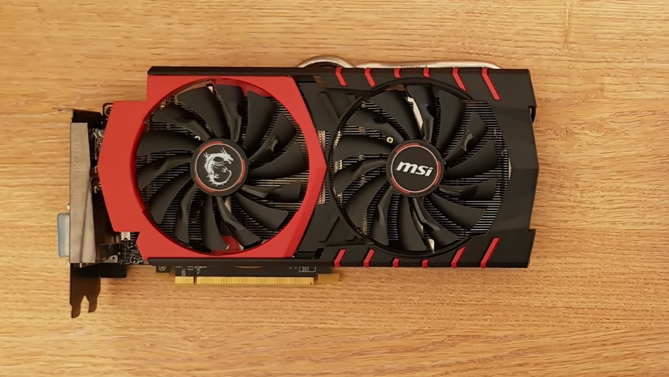

A base clock of 1050 MHz can be triggered up to 1178 MHz and the memory clock runs in 1753MHz (7Gbps effective). Again, the signified memory aka Vram is 4GB GDDR5 and operates through a 256-bit memory bus.

This dual-slot design has a 65.97GPixels pixel rate on theoretical performance rate. It ensures a bandwidth of 224.4 GB/s. It can draw the power of 148 W maximum and the card is connected to the system with a PCIe 3.0x16 interface.

### GTX 1060 3 GB

The GTX 1060 3 GB comes with a powerful architecture, Pascal that assures a dedicated gaming companion to you. It has an 80mm dual cooling fan that increases stability and cooling facility.

Being one of the starters of the leading generation model it has a 3 GB Vram (Video Memory), and the core clock speed is 1506 MHz that can boost up to 1708 MHz speed. The memory clock is calculated to be 2002 MHz (effective 8008 MHz).

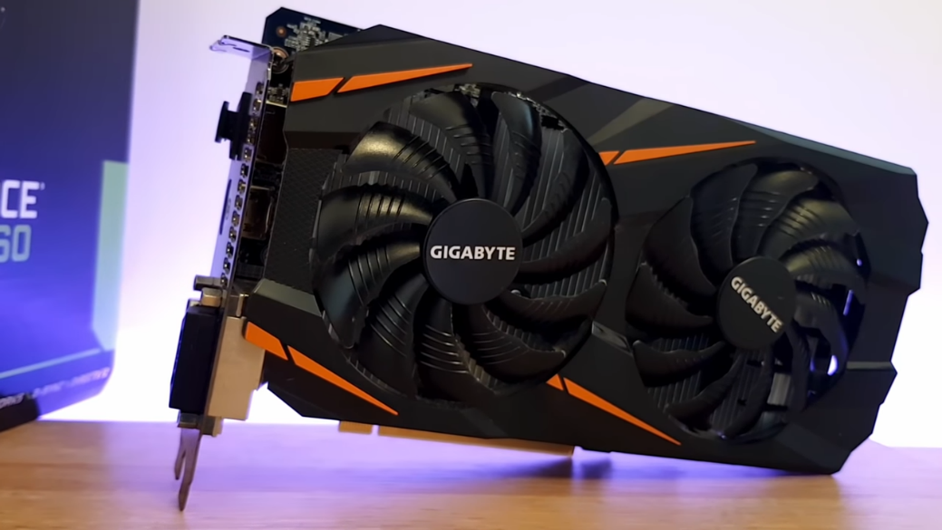

If you are to look into the memory interface it is 192-bit and creates a bandwidth of 192.2 GB/s. Its dual-slot card cooperates via PCIe 3.0x16 interface and the required pin power connector is 1x6. Again, the power it can consume is rated to 120 Watt.

The following link gives a more precise demonstration of the specs of the corresponding graphics cards <https://www.youtube.com/watch?v=uisegbaJv04>

## Is GTX 970 better or GTX 1060 3 GB

As per the speed check the GTX 970 can fight with GTX 1060 3 GB. Then again, the extra 0.5 GB with 3.5 GB in GTX 970 barely gives a notice-worthy difference. Moreover, the visual of GTX 970 results better than GTX 1060 3 GB. So, the verdict turns out to be a tough one. Overall, the benchmark rate goes towards GTX 1060 3 GB.

## Conclusion

Graphics cards are seemingly unavoidable components while upgrading your PC. So, having the proper knowledge of the specs is important in relating to your requirements. It has been a burning topic for a long, GTX 970 vs GTX 1060 3 GB and more or less it is clearer that both are preferable, and as the upcoming upgrades focus on better architectures, so GTX 1060 3 GB is the one to go for.